Supplementary Table 20. TF factor.
lnc-GNS-3
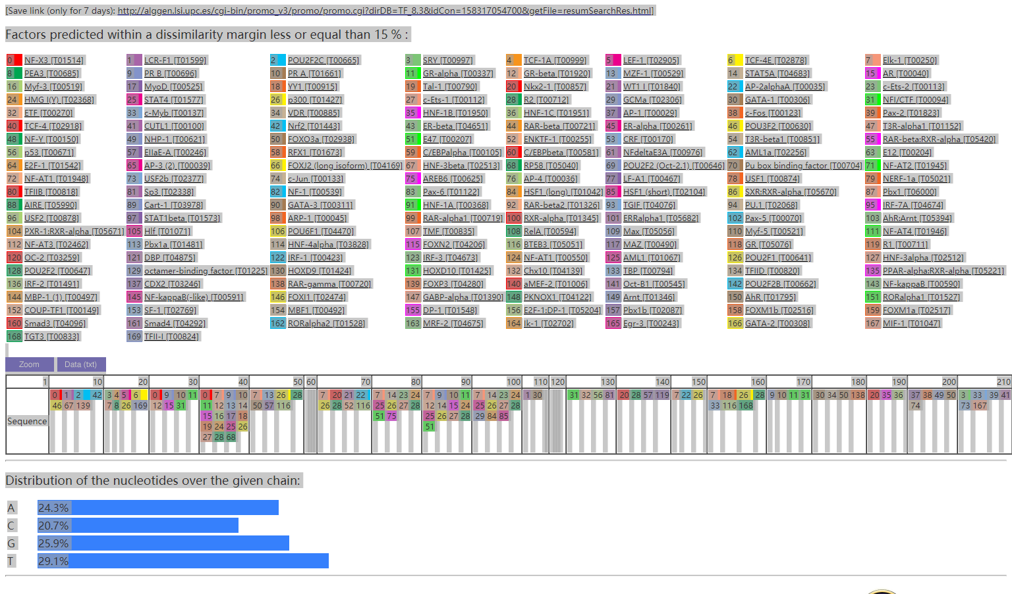
http://alggen.lsi.upc.es/cgi-bin/promo_v3/promo/promo.cgi?dirDB=TF_8.3&idCon=158317054700&getFile=resumSearchRes.html
XLOC_515910
lnc-SERHL2-7
lnc-IL31RA-1
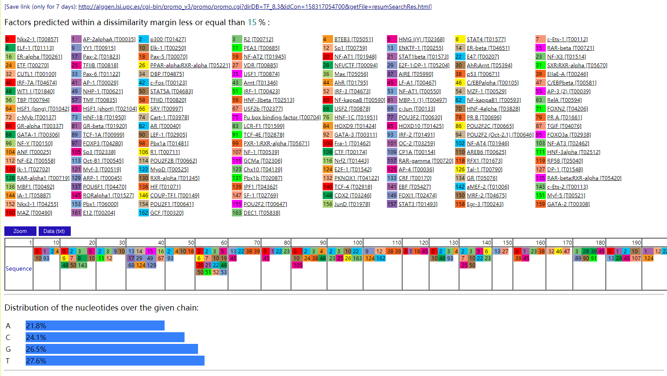
http://alggen.lsi.upc.es/cgi-bin/promo_v3/promo/promo.cgi?dirDB=TF_8.3&idCon=158317054700&getFile=resumSearchRes.html
lnc-NLRP2-2
lnc-CDK12-2
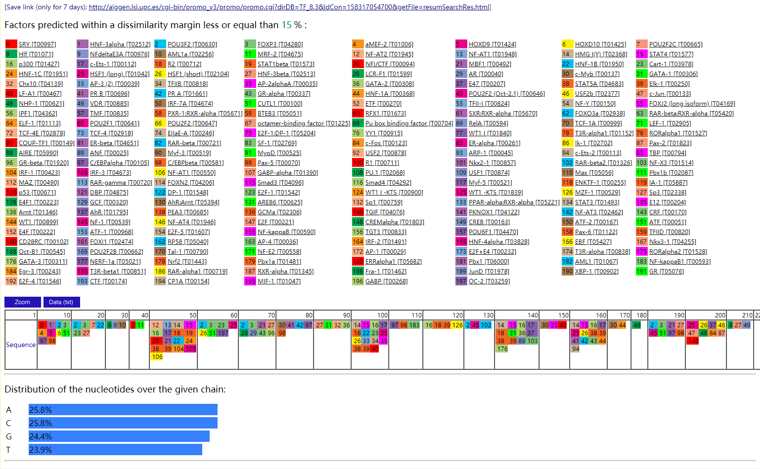
http://alggen.lsi.upc.es/cgi-bin/promo_v3/promo/promo.cgi?dirDB=TF_8.3&idCon=158317054700&getFile=resumSearchRes.html
XLOC_1093926
lnc-LRRC38-2
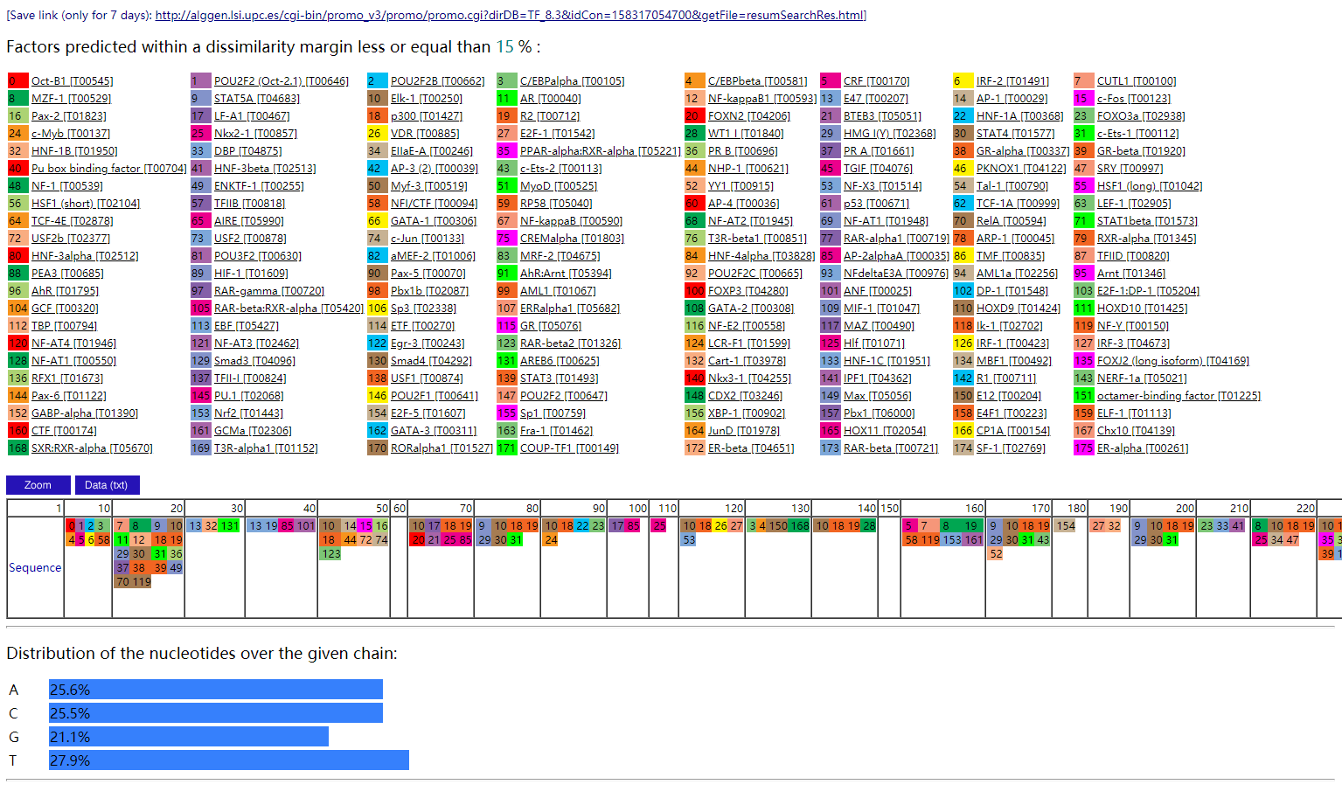
http://alggen.lsi.upc.es/cgi-bin/promo_v3/promo/promo.cgi?dirDB=TF_8.3&idCon=158317054700&getFile=resumSearchRes.html
lnc-FOXN1-1
lnc-SLC46A2-1
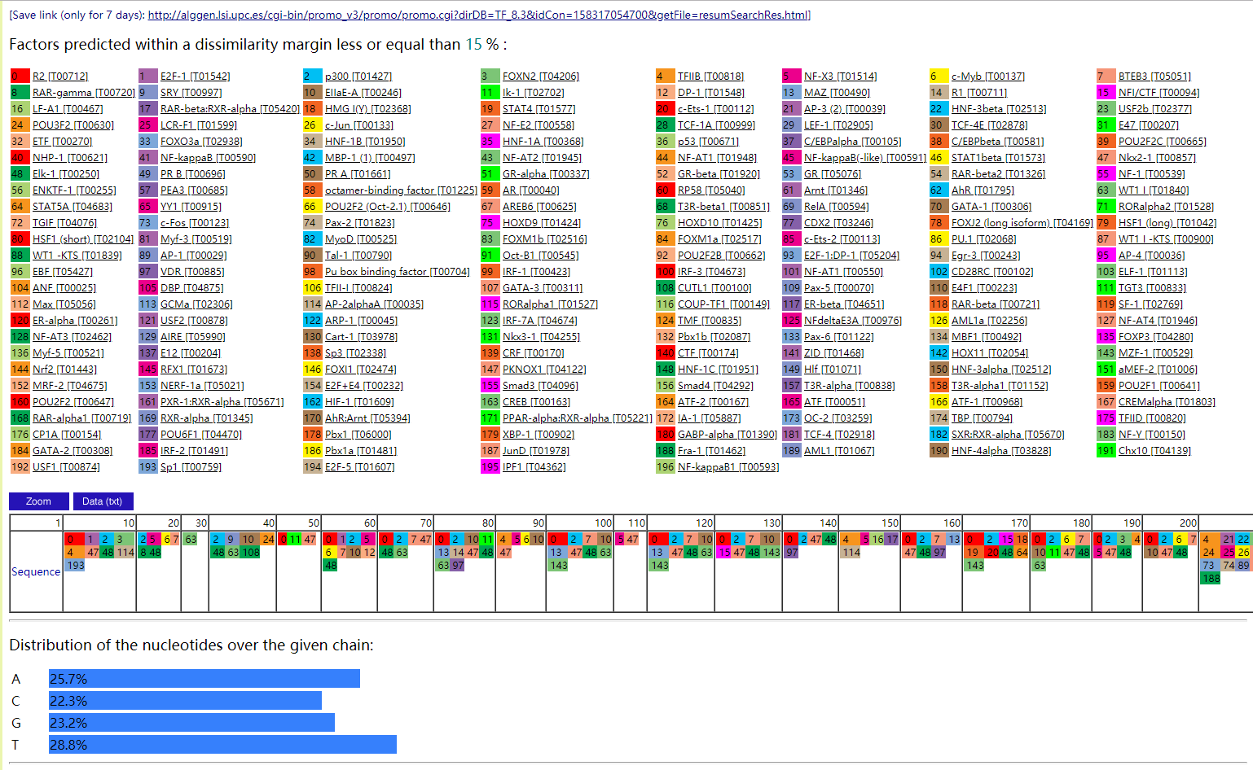
http://alggen.lsi.upc.es/cgi-bin/promo_v3/promo/promo.cgi?dirDB=TF_8.3&idCon=158317054700&getFile=resumSearchRes.html
lnc-CSNK1A1-7
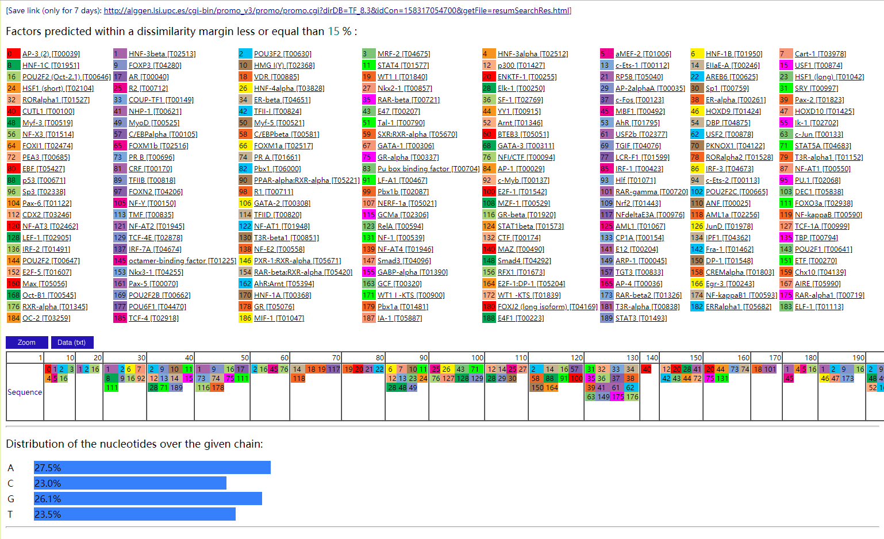
http://alggen.lsi.upc.es/cgi-bin/promo_v3/promo/promo.cgi?dirDB=TF_8.3&idCon=158317054700&getFile=resumSearchRes.html
lnc-PHLDB1-1
lnc-KB-1980E6.3.1-6
lnc-LAT2-2
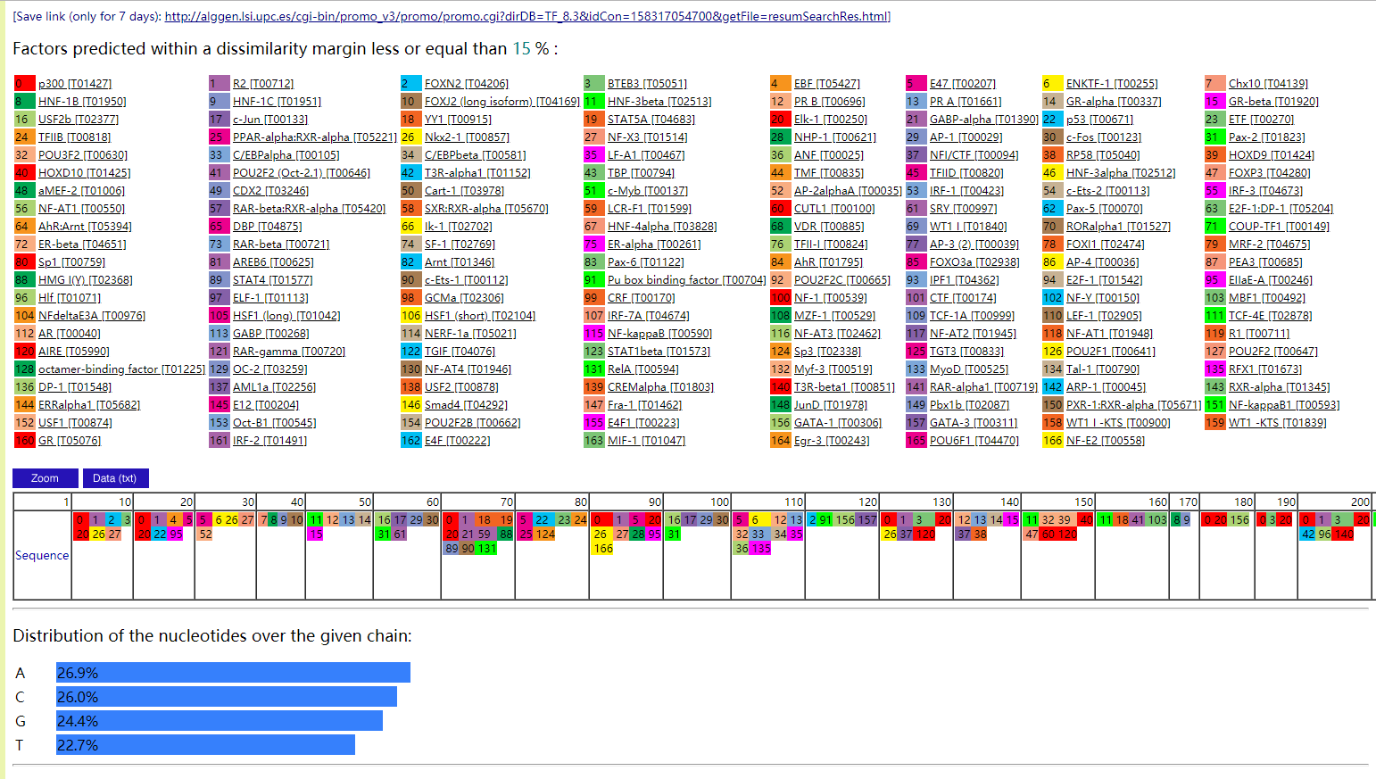
http://alggen.lsi.upc.es/cgi-bin/promo_v3/promo/promo.cgi?dirDB=TF_8.3&idCon=158317054700&getFile=resumSearchRes.html
XLOC_2394941
lnc-EEF1B2-3
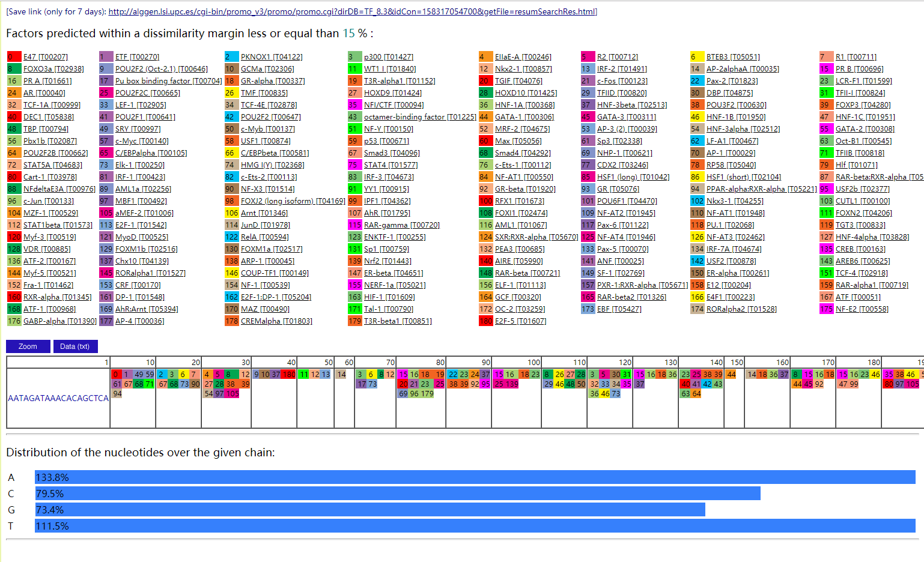
http://alggen.lsi.upc.es/cgi-bin/promo_v3/promo/promo.cgi?dirDB=TF_8.3&idCon=158317054700&getFile=resumSearchRes.html
lnc-AP3S1-15
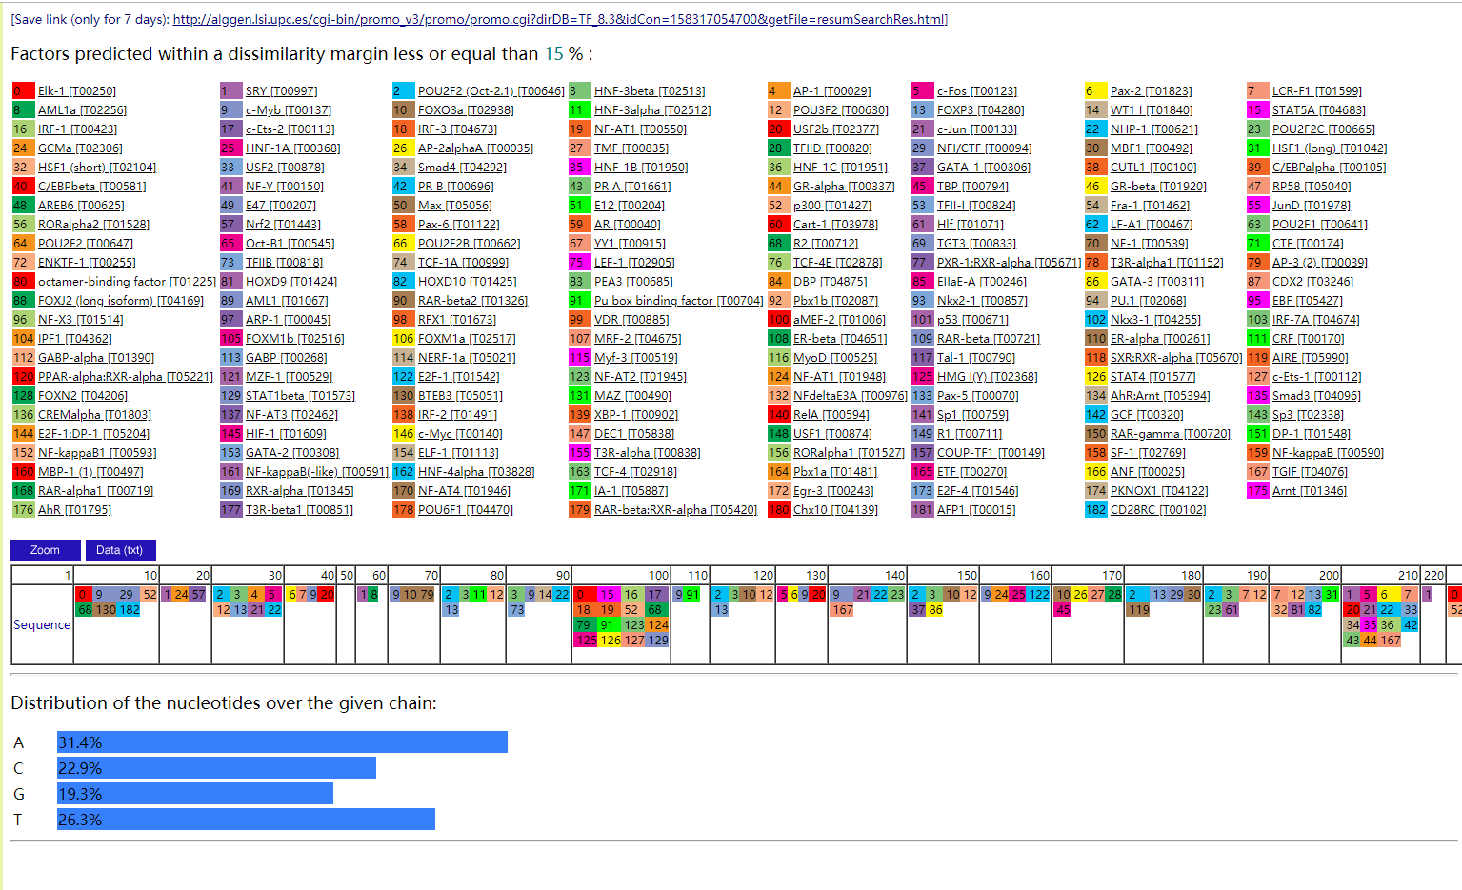
http://alggen.lsi.upc.es/cgi-bin/promo_v3/promo/promo.cgi?dirDB=TF_8.3&idCon=158317054700&getFile=resumSearchRes.html
lnc-SLA2-1
lnc-RAPH1-6
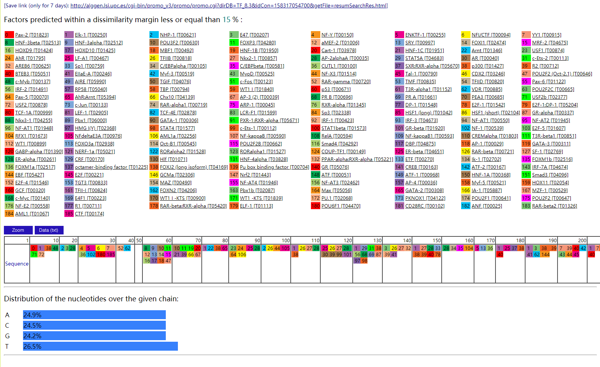
http://alggen.lsi.upc.es/cgi-bin/promo_v3/promo/promo.cgi?dirDB=TF_8.3&idCon=158317054700&getFile=resumSearchRes.html
lnc-TICAM1-1
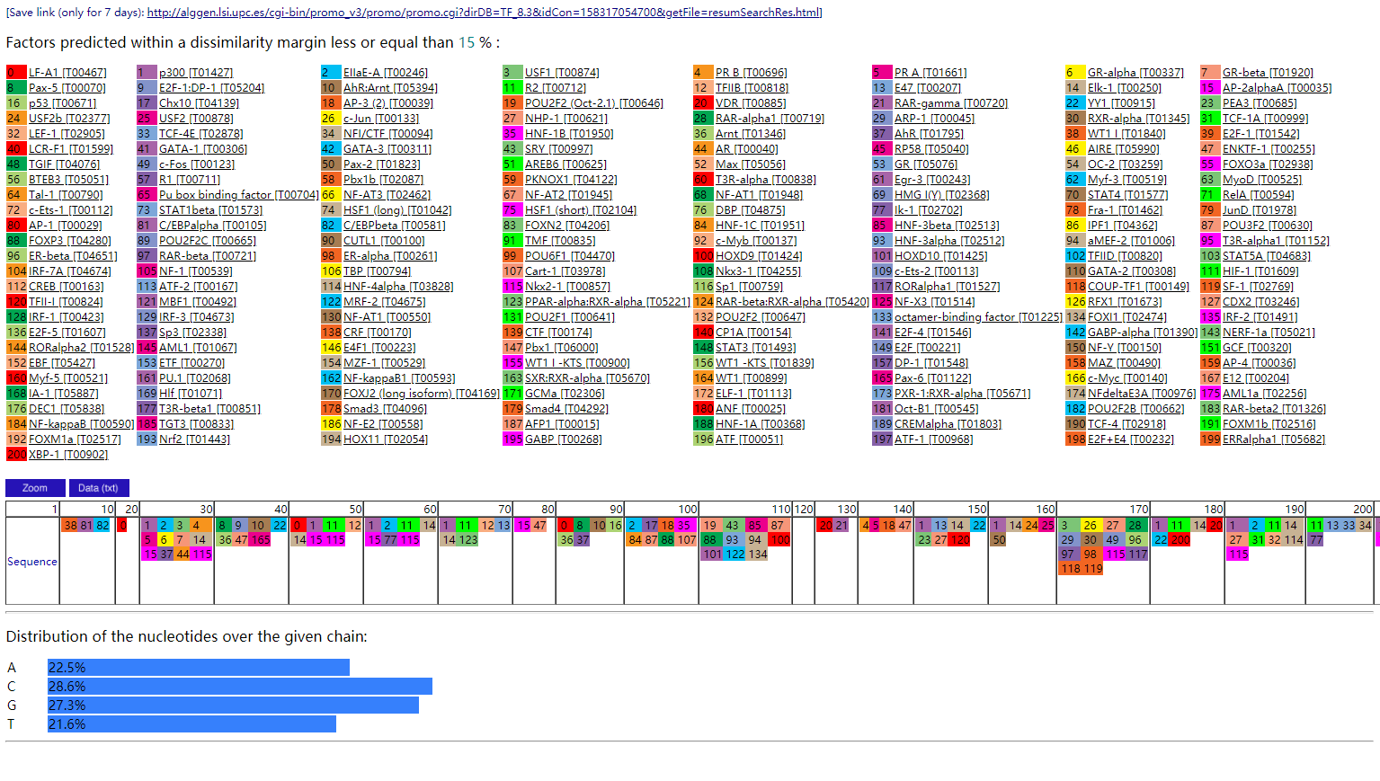
http://alggen.lsi.upc.es/cgi-bin/promo_v3/promo/promo.cgi?dirDB=TF_8.3&idCon=158317054700&getFile=resumSearchRes.html

lnc-AC007390.5.1-4
lnc-TSKS-1
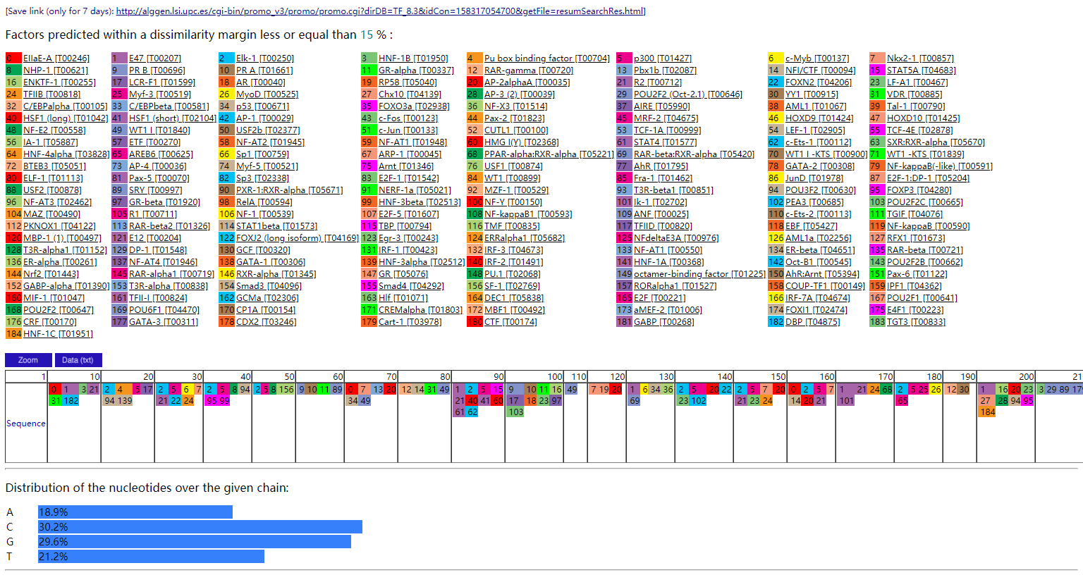
http://alggen.lsi.upc.es/cgi-bin/promo_v3/promo/promo.cgi?dirDB=TF_8.3&idCon=158317054700&getFile=resumSearchRes.html
lnc-TUFM-1
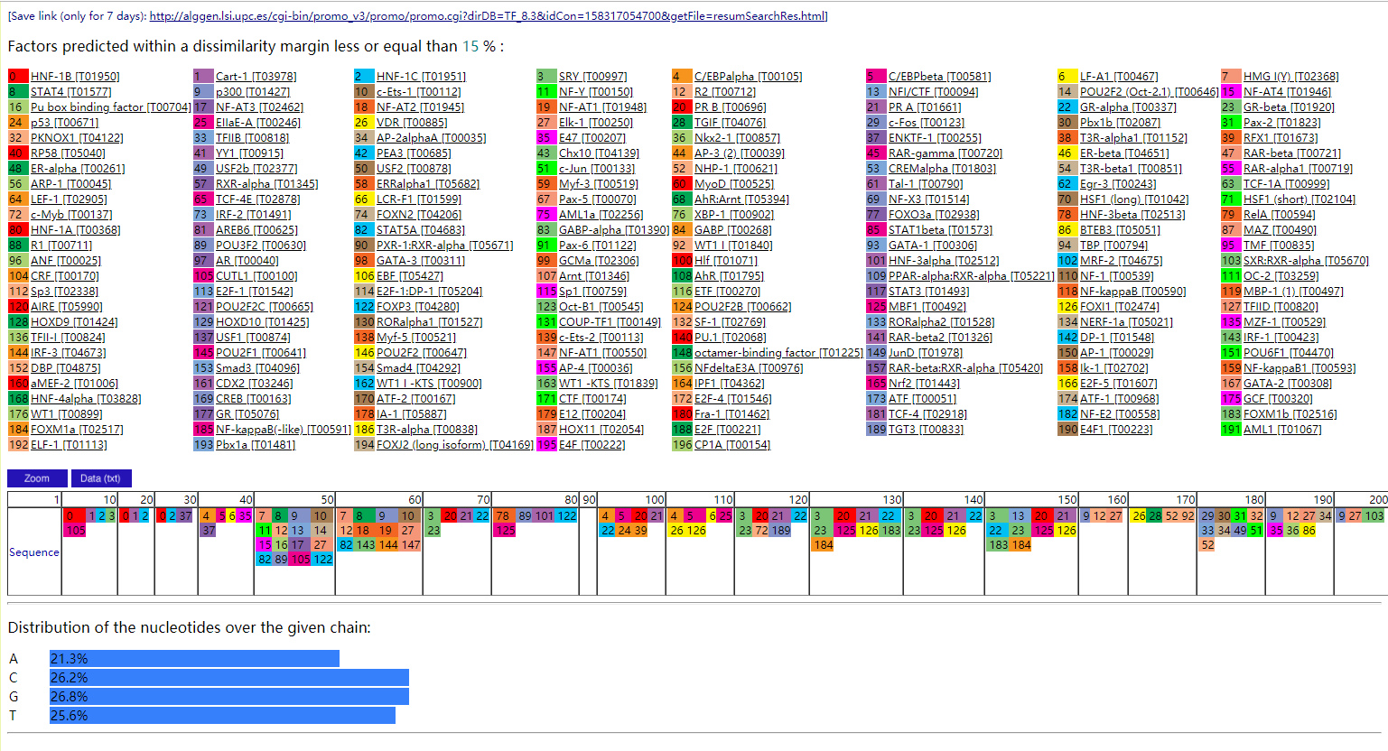
http://alggen.lsi.upc.es/cgi-bin/promo_v3/promo/promo.cgi?dirDB=TF_8.3&idCon=158317054700&getFile=resumSearchRes.html
lnc-VRK3-2
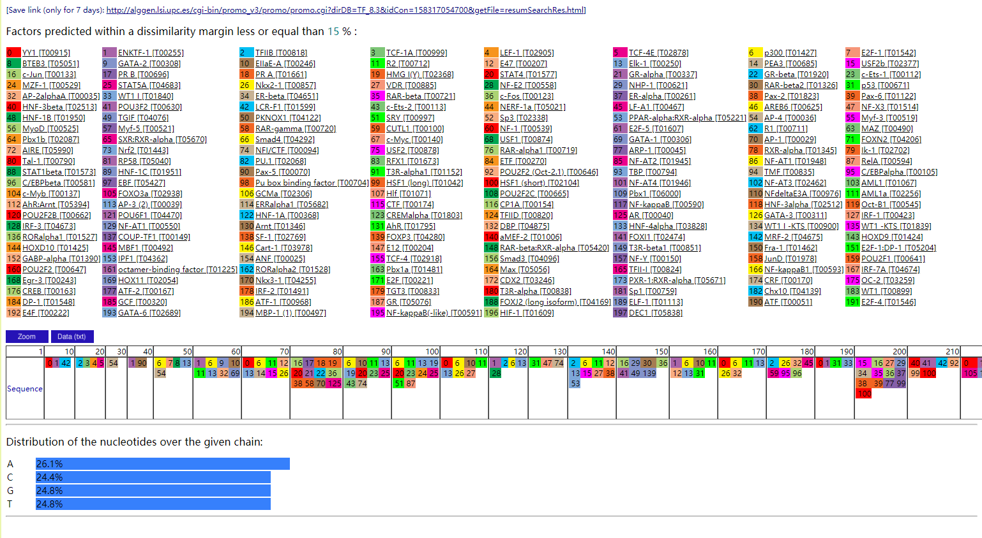
http://alggen.lsi.upc.es/cgi-bin/promo_v3/promo/promo.cgi?dirDB=TF_8.3&idCon=158317054700&getFile=resumSearchRes.html
lnc-SPATA21-3
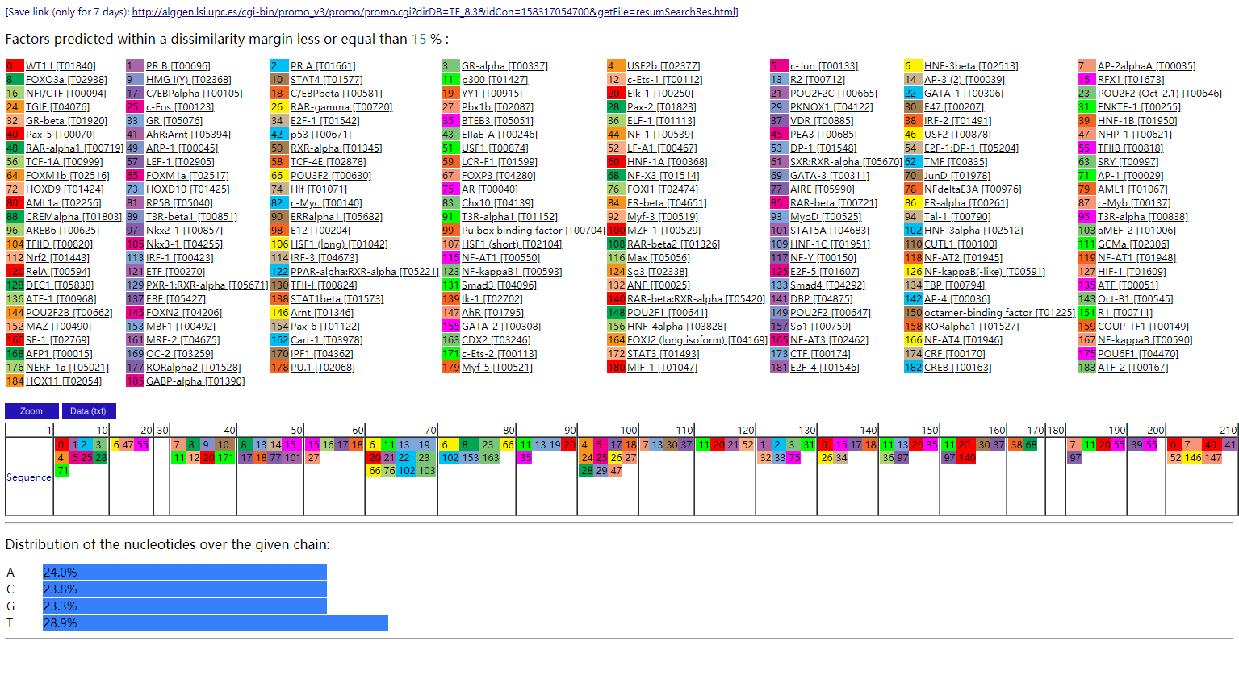
http://alggen.lsi.upc.es/cgi-bin/promo_v3/promo/promo.cgi?dirDB=TF_8.3&idCon=158317054700&getFile=resumSearchRes.html

lnc-LRRC1-5
lnc-PRR15L-2
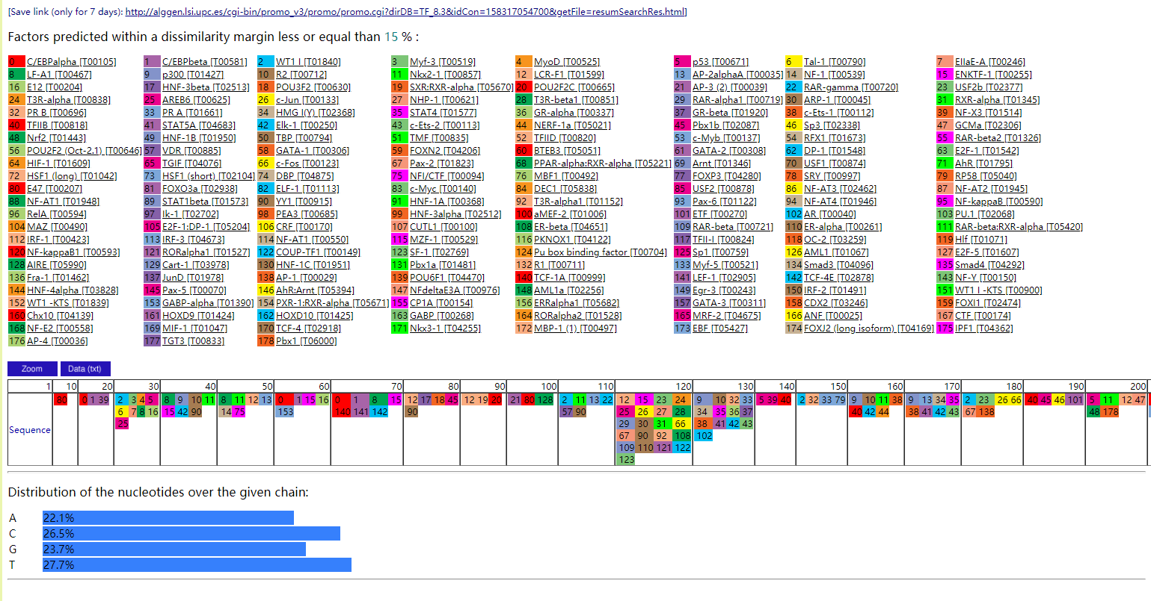
http://alggen.lsi.upc.es/cgi-bin/promo_v3/promo/promo.cgi?dirDB=TF_8.3&idCon=158317054700&getFile=resumSearchRes.html
lnc-PRR15L-3
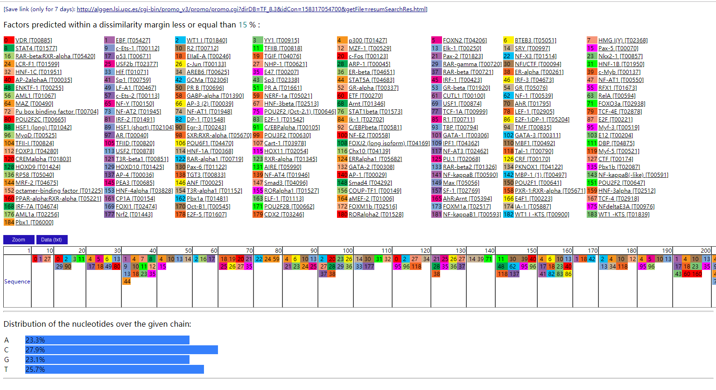
http://alggen.lsi.upc.es/cgi-bin/promo_v3/promo/promo.cgi?dirDB=TF_8.3&idCon=158317054700&getFile=resumSearchRes.html

lnc-C4orf21-1
lnc-NT5DC2-1
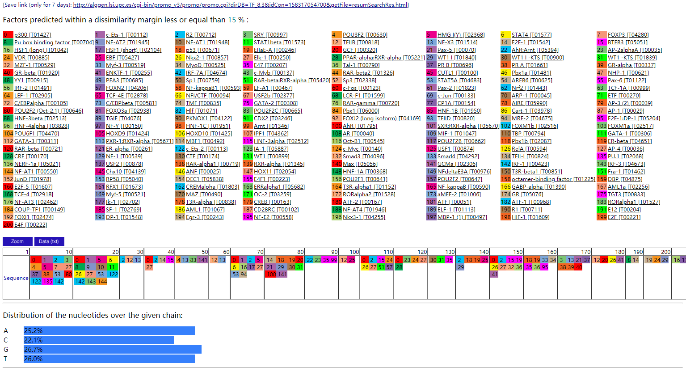
http://alggen.lsi.upc.es/cgi-bin/promo_v3/promo/promo.cgi?dirDB=TF_8.3&idCon=158317054700&getFile=resumSearchRes.html

lnc-NUDT5-1
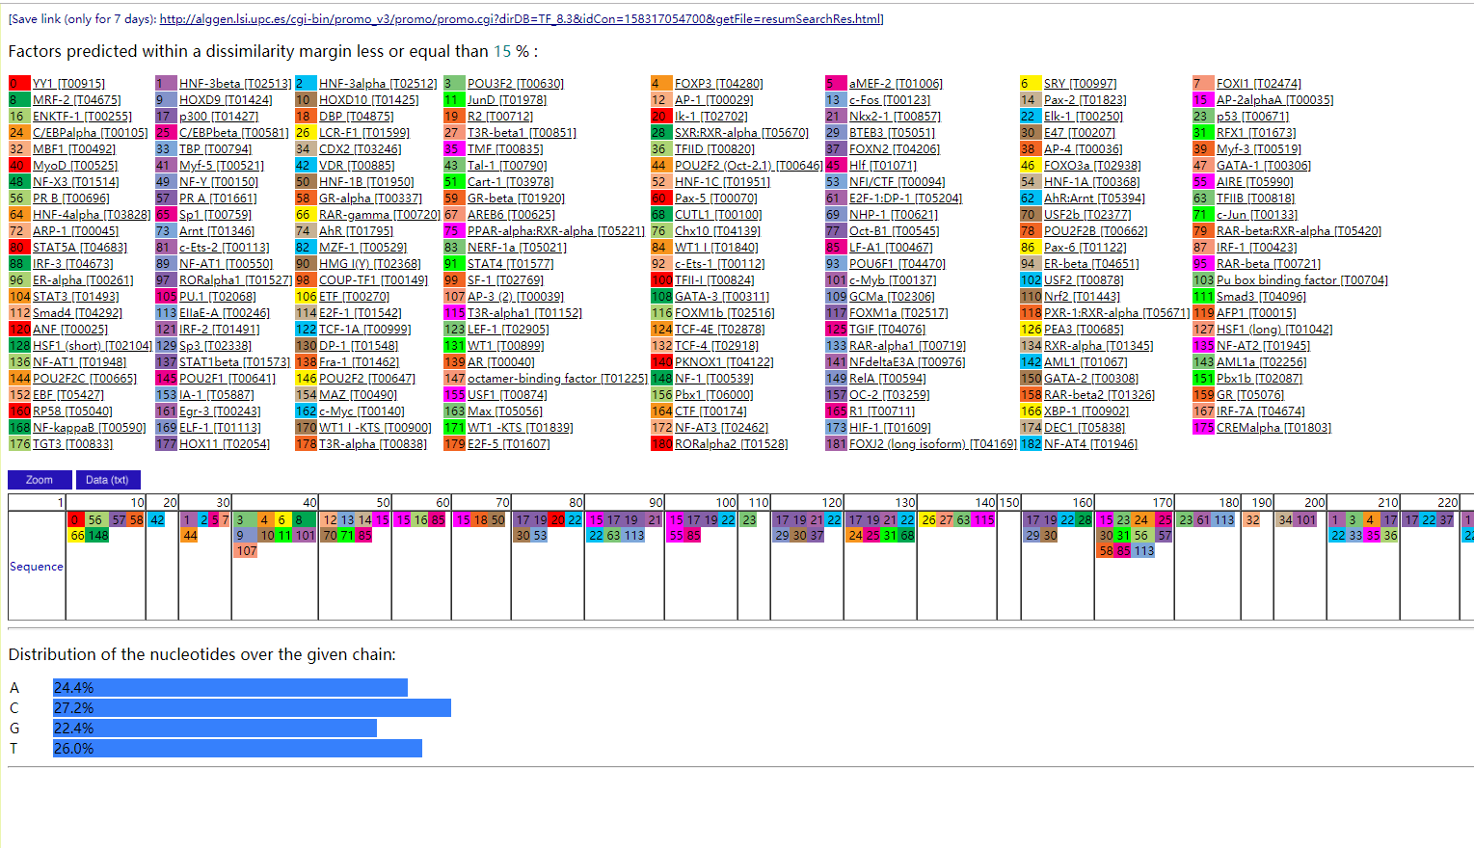
http://alggen.lsi.upc.es/cgi-bin/promo_v3/promo/promo.cgi?dirDB=TF_8.3&idCon=158317054700&getFile=resumSearchRes.html
XLOC_000127

